

Year 8 Science
Task 10: Physics 1 Test 2018 Name:______

SECTION 1: MULTIPLE CHOICE (1 mark each)
Circle your answer on the multiple choice answer sheet.

- Which is the best definition of energy?
  - A measure of the ability to do work.
  - A measure of the motion of an object.
  - A measure of the temperature of something.
  - A measure of the amount of matter in an object.

- An object that is sitting still on the top of a hill has
  - a lot of potential energy and not much kinetic energy.
  - a lot of kinetic energy and not much potential energy.
  - a lot of kinetic and potential energy.
  - not much kinetic or potential energy.

- Energy is measured in
  - metres (m)
  - Newtons (N)
  - Joules (J)
  - Watts (W)

- Which of these is not a type of energy?
  - elastic
  - light
  - heat
  - pushing

- Which type of energy is contained in food?
  - mechanical
  - chemical
  - solar
  - nuclear

- Which of these is not a sustainable or renewable energy source?
  - solar panels
  - wind turbines
  - diesel generator
  - wave generator

- The original source of all energy on Earth is
  - the sun.
  - plants.
  - fossil fuels.
  - food.

- A hair dryer works by which of the following energy transfers and transformations?
  - Electrical energy is converted to heat energy and kinetic energy.
  - Heat energy is converted to electrical energy and kinetic energy.
  - Kinetic energy is converted to heat energy and electrical energy.
  - Heat energy and kinetic energy are converted to electrical energy.

- In a light bulb, the useful energy output is
  - sound.
  - heat.
  - light.
  - electric.

- Which of the following best describes the energy transformation within a microphone?
  - Kinetic energy is converted to sound energy.
  - Kinetic energy is converted to potential energy.
  - Electrical energy is converted to kinetic energy.
  - Kinetic energy is converted to electrical energy.

SECTION 2: WRITTEN
Write your answers in the spaces on the answer sheet provided.

- Classify each of these energy types as kinetic or potential (5)
- chemical
- elastic
- gravitational
- heat
- sound

- Copy and complete the table below. (9)

Appliance | Input Energy | Source | Output Energy | Receiver
electric toaster | (a) | power point | (b) | (c)
solar hot water system | (d) | (e) | heat | (f)
petrol engine | chemical | (g) | (h) | (i)

- State two problems that are associated with using fossil fuels (2)

- A hot water system is 65% efficient. If it is supplied with 1000 Joules of energy, how much heat energy will it produce? (2)

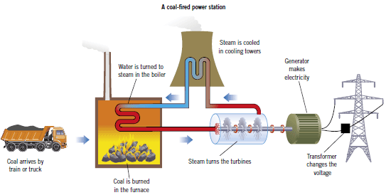
- Draw an energy flow diagram to represent the coal fired power station shown in the diagram below (2)

END OF TEST (OUT OF 30 MARKS)

